**Decision Making**

**1).If statement**

**2).if…else statement**

**3).Nested if Statements**

**4).Switch statement**

**1). If statement:**

**Syntax:**

if(boolean_expression) {

/* statement(s) will execute if the boolean expression is true */ }

🡪If the Boolean expression evaluates to true, then the block of code inside the ‘if’ statement will be executed

🡪If the Boolean expression evaluates to false, then after the end of the ‘if’ statement (after the closing curly brace) will be executed

**Example:**

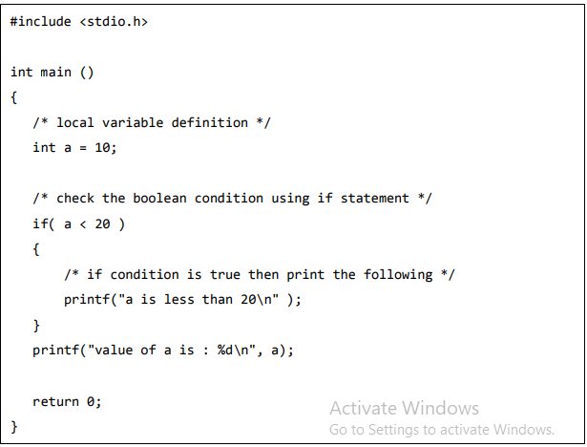

**If-else statement:**

**Syntax:**

if(boolean_expression) {

/* statement(s) will execute if the boolean expression is true */

}

else {

/* statement(s) will execute if the boolean expression is false */

}

**🡪**If the Boolean expression evaluates to true, then the if block will be executed, otherwise, the else block will be executed.

**Example:**

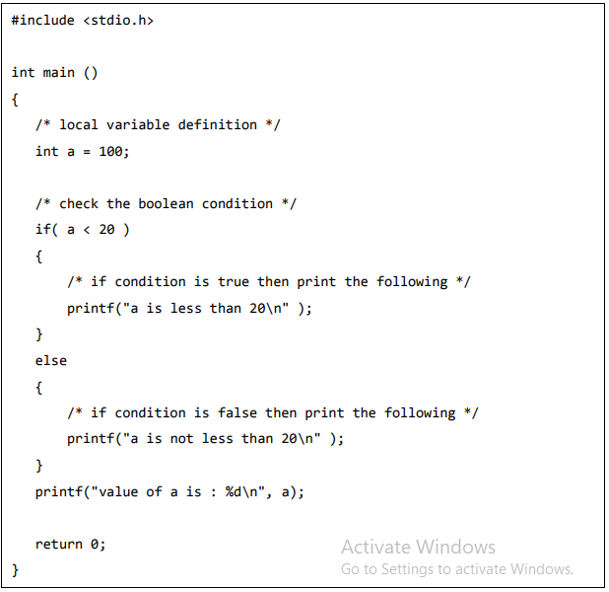

**If.else if..else statement:**

**Syntax:**

if(boolean_expression 1) {

/* Executes when the boolean expression 1 is true */

}

else if( boolean_expression 2) {

/* Executes when the boolean expression 2 is true */

}

else if( boolean_expression 3)

{

/* Executes when the boolean expression 3 is true */

}

else {

/* executes when the none of the above condition is true */

}

**Example:**

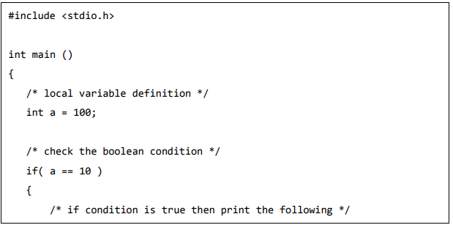

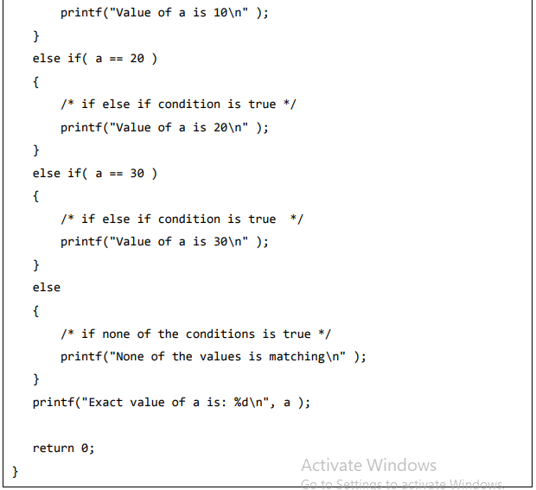

**Nested if Statements:**

**Syntax:**

if( boolean_expression 1) {

/* Executes when the boolean expression 1 is true */

if(boolean_expression 2) {

/* Executes when the boolean expression 2 is true */

}

}

**Example:**

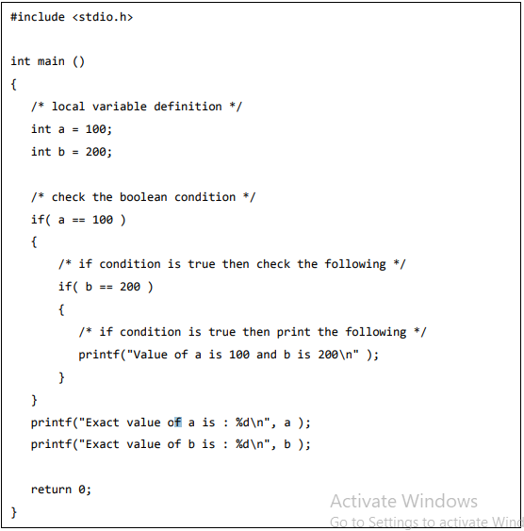

**Switch Statements:**

**Syntax:**

switch(expression){

case constant-expression : statement(s);

break; /* optional */

case constant-expression :

statement(s);

break; /* optional */

/* you can have any number of case statements */

default : /* Optional */

statement(s);

}

**Example:**

